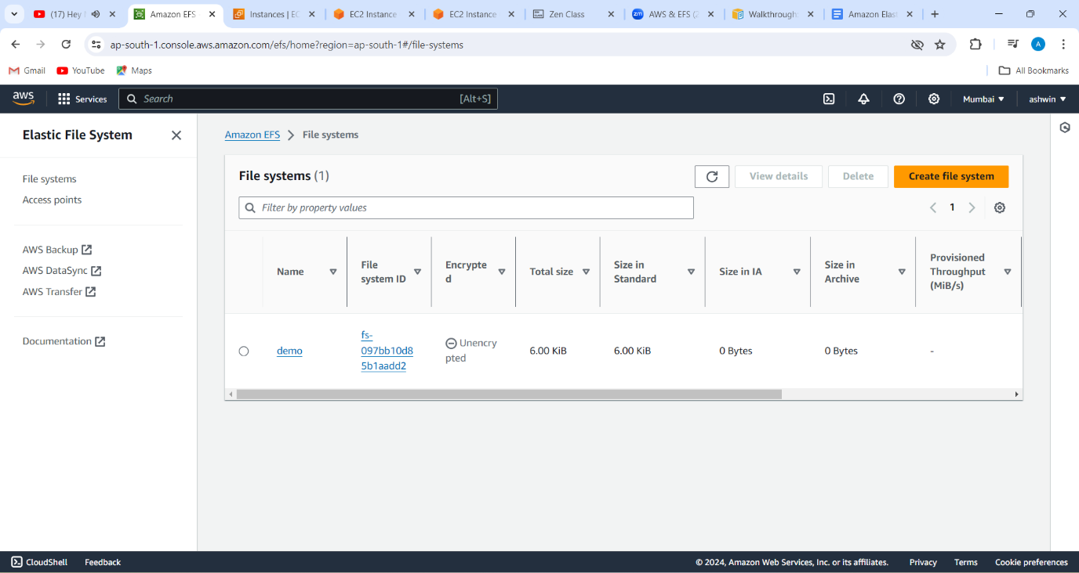

1(created a efs)

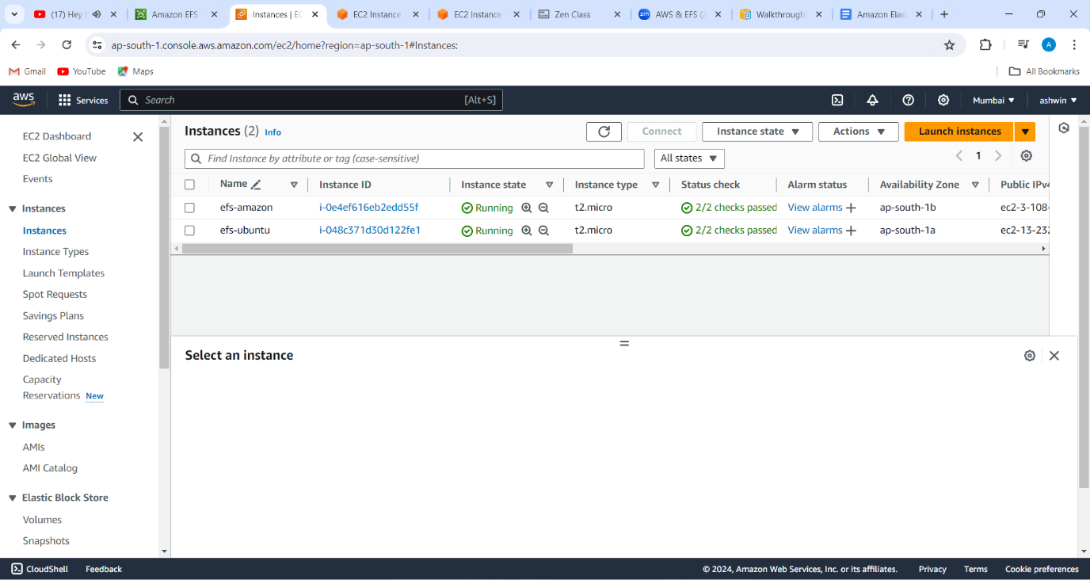2(created 2 ec2 machines in ubuntu and amazon lin)

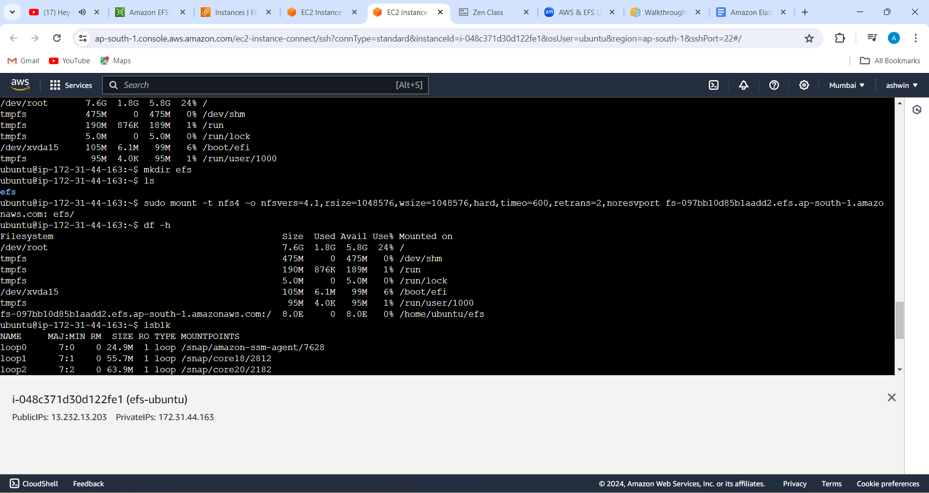

3(configured efs in ubuntu server)

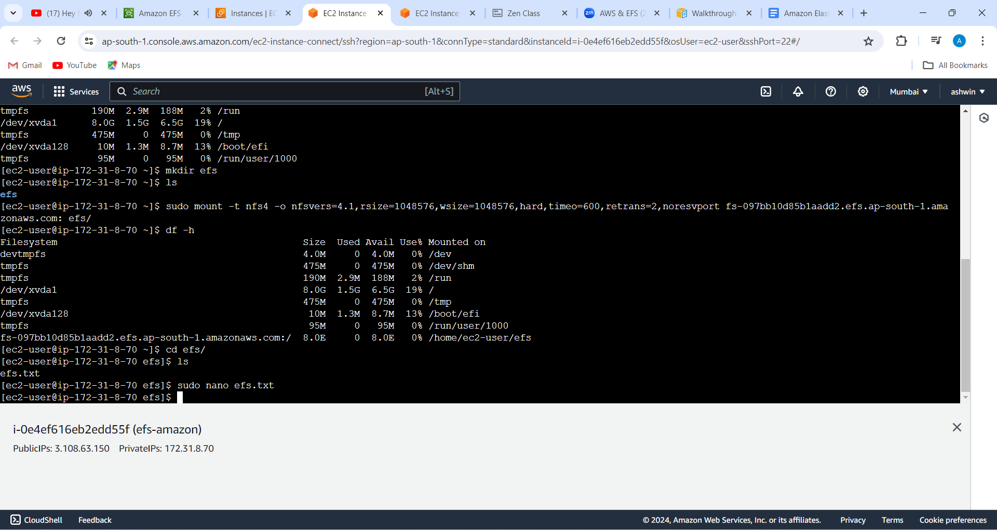

4(configured efs in amazon linux)

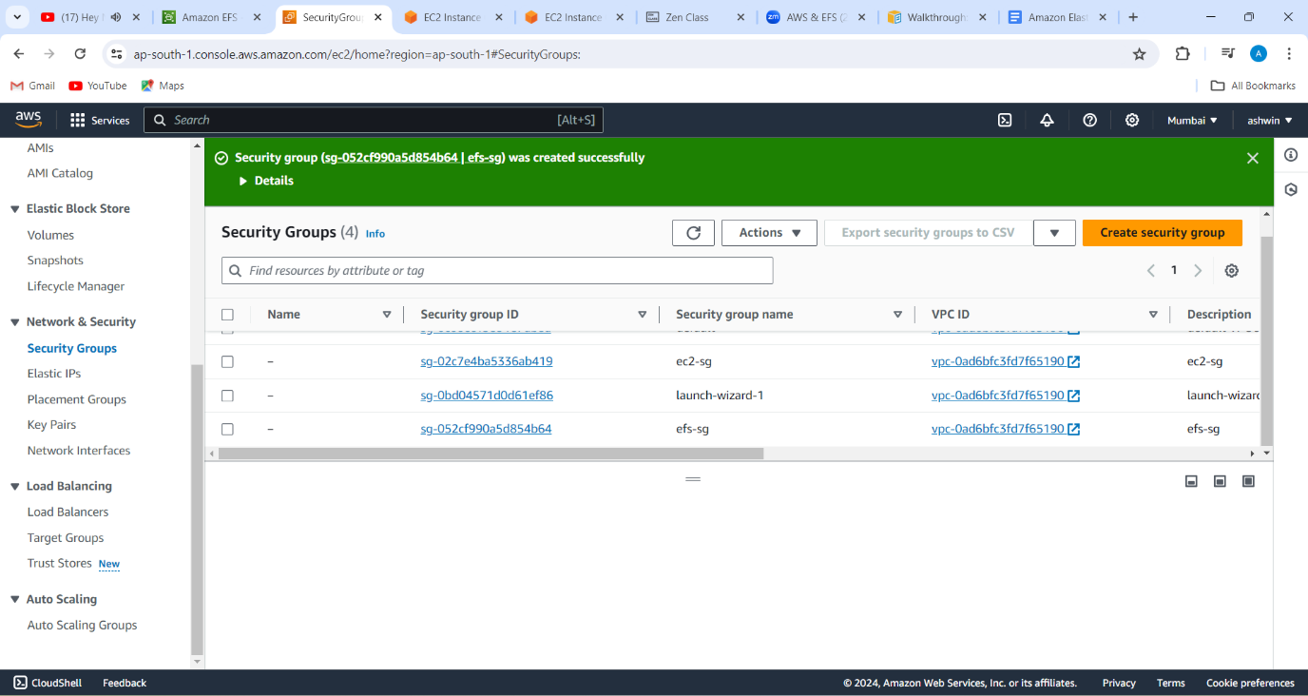

5(created 2 sgs one for ec2 servers other for efs and connect efs sg to ec2 sgs)